****SMM 27 Conference

Torino 8 – 11 September 2025

<https://smm27.polito.it>

[smm27@polito.it](mailto:smm27@polito.it)

Conference Chairs: Carlo Appino and Carlo Ragusa

This is the template to submit your abstracts to the SMM27 Conference. Please fill in the mandatory metadata in the table below, then type your abstract on the next page. Send us by e-mail at [smm27@polito.it](mailto:smm27@polito.it) this whole document, both in docx and in pdf format.

|  |  |  |
| --- | --- | --- |
| **Full name** |  | Please type here the presenting author’s full name. |
| **e-mail address** |  | Please type here the presenting author’s e-mail address. |
| **Abstract title** |  | Please type here the abstract title. It must be the same as the one in the next page. |
| **Full list of authors** |  | Please type here the full list of authors co-signing the abstract. It must be the same as the one in the next page. Use semicolons ( ; ) as separators. |
| **Scientific topic** |  | Pick the topic where your abstract best fits into. Refer to the web site. |
| **Keywords** |  | Please specify at least one keyword describing your abstract. In case of more than one keyword, use semicolons ( ; ) as separators. |
| **Preferred presentation method** |  | Please specify either oral or poster. |

Type here your abstract title: please use lowercase letters and do not capitalize words

Paul Langevina, Galileo Ferrarisb, Car F. Gaussc

*a Collège de France, Paris, France. bSchool of Electrotechnics, Regio Museo Industriale, Torino, Italy. cUniversity of Göttingen, Göttingen, Germany.*

This is the template file for the abstracts to be submitted to the SMM27 conference [1]. Use MS-Word to edit this file. Replace text where appropriate, preserving font sizes, spaces, and the provided formatting. Write full author names, and underline the corresponding / presenting author. Use this first section for a brief summary (5-to-10 lines of text).

Keywords: at least one keyword; use semicolons as separators; three to five keywords recommended

# Introduction

Provide a brief introduction to your work. You can add references to relevant existing literature [1,2]. Please give enough context for the referees to properly evaluate your abstract and place it in the correct conference session.

# Results and discussion

Provide a concise summary of the main results of your work, with appropriate comments and discussion. You can make use of in-line mathematical expressions such as $∇∙\vec{B}=0$, or more complex equations:

$$∇×\vec{H}=\vec{J}+ε_{0}\frac{∂\vec{E}}{∂t} \left(1\right)$$

You can insert one or two figures in line with the text, with a descriptive caption underneath. Use of colour figures when appropriate is encouraged and recommended. Figure 1 provides an example.

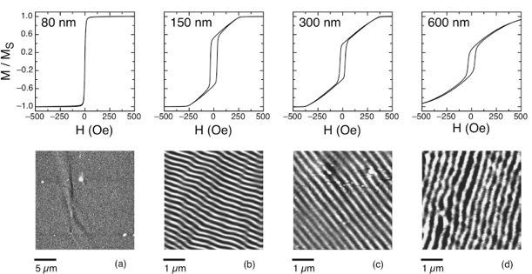

Figure 1: Top row: hysteresis loops of samples with different thickness. Bottom row: corresponding MFM images at remanence.

Please stay within the one-page limit: abstracts exceeding this length will be rejected or their length trimmed. The complete abstract file will, therefore, consist of two pages: the front page with the summary data and metadata and the one-page scientific digest.

Submit your abstract file by email [3] following the instructions provided on the Conference website [1]. Please prepare an MS Word and a PDF version of your abstract file, and submit both as attachments to the same email message. If you need to apply changes or corrections to an already submitted abstract or withdraw it, please send us an email [3].

Thank you for contributing to the SMM27 conference, and see you in Torino in September 2025.

# References

[1] https://www.smm27.polito.it.

[2] L. Néel, Rev. Mod. Phys. **25** (1953), 58-63.

[3] smm27@polito.it

Acknowledgements: Insert here any acknowledgements to laboratories, infrastructures, colleagues, projects, funding agencies, etc, that are relevant to your work.